**LMS Project Report**

**User Authentication Code:**

**User Login Screenshots:  
Admin Output- Borrower Ouput-**

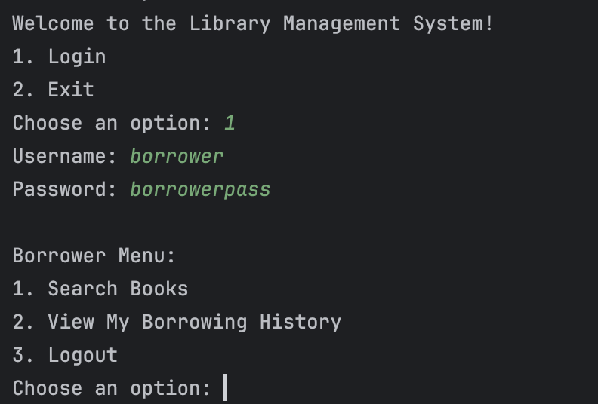

**Add Book Operation Code :**

**Add Book Output Screenshots:**

**Add Book Copies Operation Code:**

**Add Book Copies Operation Output:**

**Add Borrower Operation Code:**

**Add Borrower Operation Output:**

**Add Borrower Book Operation Code:**

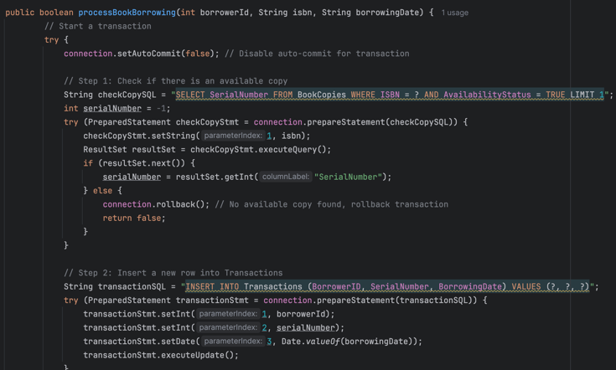

**Add Borrower Book Operation Output:**

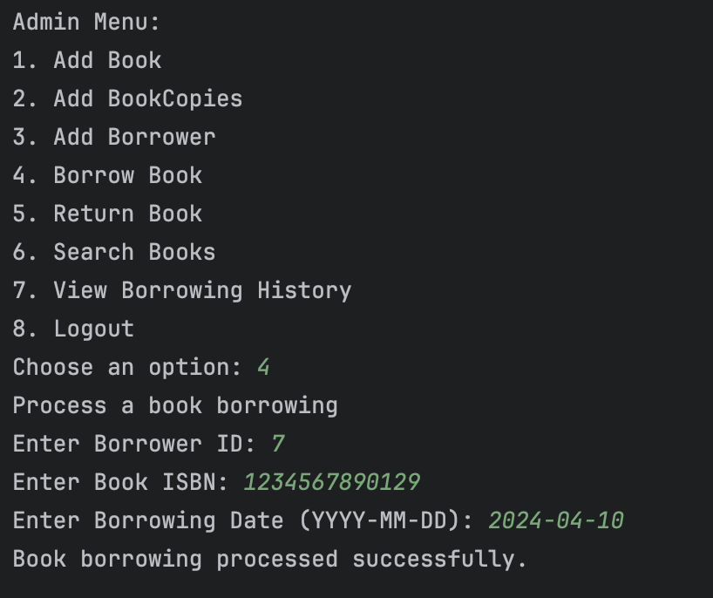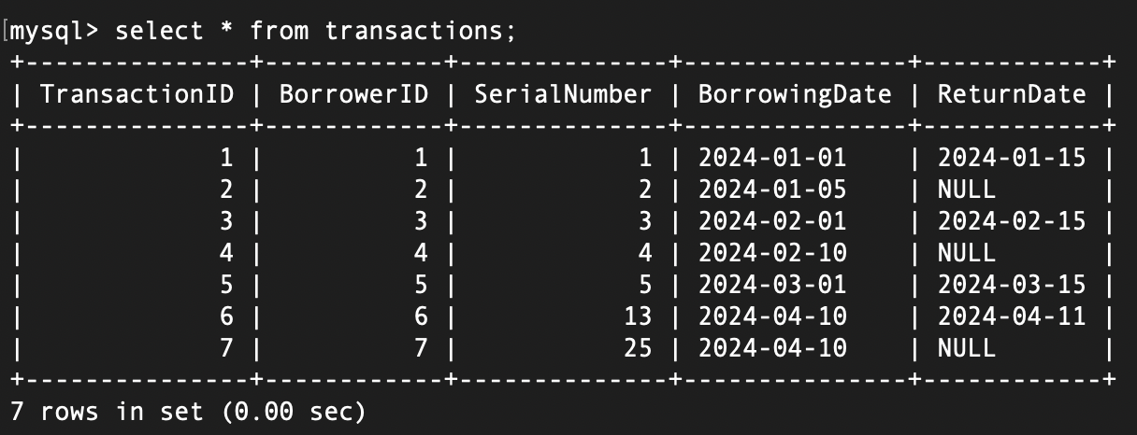

**Add Return Book Operation Code:  
**

**Add Return Book Operation Output:**

**Add View Borrowing History Code:**

**Add View Borrowing History Output:**

**Borrower Access of History:**

**Search Logic:**



